Financial Report  
June 2017

# Balance Sheet

|  |  |  |  |  |
| --- | --- | --- | --- | --- |
| Item | | | Out | In |
| **Balance 1 January 2016** | | |  | **£4,961.63** |
| Transferred from Co-Op | | |  | £757.90 |
| Committee meeting: Nov 2015 & Nov 2016 | | | -£913.43 |  |
| Special Interest Group | | | -£97.44 |  |
| Sundries | | | -£55.60 | £477.53 |
| Donation to PHI | | | -£500.00 |  |
| Spring Forum 2016 | | | -£3,983.22 | £8,217.24 |
| Summer Conference 2016 | | |  |  |
| Ticket sales | |  | £6,795.10 |
| Venue fees | | -£6,322.65 |  |
| Eventbrite fees | | -£145.10 |  |
| Speaker expenses | | -£72.23 |  |
| Sundries | | -£62.06 |  |
| **Balance 1 January 2017** | | |  | **£9,057.67** |
| Corporate membership 2017 | | |  | £4,994.00 |
| Spring Forum 2017 | | |  |  |
| Ticket sales | |  | £7,326.42 |
| Venue fees | | -£4,710.60 |  |
| Eventbrite fees | | -£371.21 |  |
| Speaker expenses | | -£538.30 |  |
| Sundries (inc. red noses) | | -£116.94 |  |
| Summer Conference 2017 | | |  |  |
| Ticket sales | |  | £1,690.00 |
| Venue fees | | -£8,649.00 |  |
| **Balance 23 June 2017** | | |  | **£8,682.04** |
| Pending transactions | | |  |  |
| Corporate membership 2017 | |  | £1,000.00 |
| Spring Forum 2017 | |  |  |
| Speaker expenses | -£72.01 |  |
| Ticket sales |  | £544.79 |
| Summer conference 2017 | |  |  |
| Ticket sales: credit card |  | £1,980.00 |
| Ticket sales: invoiced |  | £1,030.00 |
| Eventbrite fees | -£269.73 |  |
| Speaker expenses (est.) | -£1,800.00 |  |
| Drinks reception + additional wine for meal (est.) | -£500.00 |  |
| Committee meeting: Nov 2017 (est.) | | -£500.00 |  |
| **Year end projected balance** | | |  | **£10,095.09** |

# Notes

* We have received 93.1% of expected income from the Spring Forum
* …and 54.9% of expected income from the Summer Conference (inc. credit cards)
* One corporate member has yet to pay their membership fee

## Documentation & Auditing

Manuals for financial policies and procedures are being created. All documentation is being archived on both Dropbox and in a printed file. Richard Osborn has kindly agreed to independently audit our accounts.

## PayPal

We can now accept payments via PayPal: [www.paypal.me/uhmlg](http://www.paypal.me/uhmlg)

## Co-Op Account

We have closed our old Co-Op account, and are now only using Barclays.

## VAT & Charitable Status

Thanks to feedback from Shirley Millar of the Business Librarians Association, I have seen guidance from the Gov.UK website that states we do not need to be VAT registered until our turnover hits £83,000 p.a. Our turnover in 2016 from the two conferences was £15,132.22.

[www.gov.uk/vat-registration](http://www.gov.uk/vat-registration)

As a result, we do not need to go any further with considerations about charitable status – we are fine to continue operating as we do currently.

## Account Balance

We are aiming to achieve a steady account balance of about £16k (enough to cover a year’s worth of expenditure with no income). We have made some initial adjustments to event ticket prices, and are making good progress towards our target balance.

### Current Account Chart, January 2016 – June 2017

Income for each event arrives both before and after then event – the sharp drop in our account holdings mark the events themselves, as we pay the venue fees (the most significant outgoings we have).

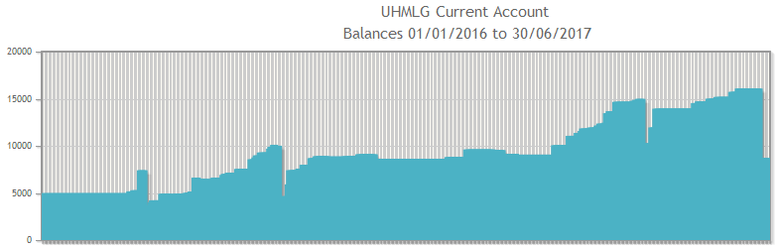

2017 Summer Conference

2017 Spring Forum

2016 Summer Conference

2016 Spring Forum

Ric Paul, Treasurer, 26 June 2017